|  |  |  |  |  |  |  |
| --- | --- | --- | --- | --- | --- | --- |
| **Jan De Nul Dredging** N.V. | |  | Procedure | | | |
|  |  |  | ***Author:*** | **Willem Braem – Tom Fermans** | | |
|  | *Creation date:* | 07/09/2016 |  |  |
|  | *Document date:* | 05/07/2017 | *Version : :* | 1.1 |
|  | | | | | | |
| **Rajant Wifi 2295 Installation** | | | | | | |

# Description

To interconnect all vessels in a full WIFI mesh network we need to equip every endpoint with a Rajant L X5 unit. Primary use for this system is to transfer surveydata between vessels on project. Secondary can this system be used to provide internet access for the vessel/endpoint.

# Hardware required

## Hardware

### Rajant LX5

#### Overview

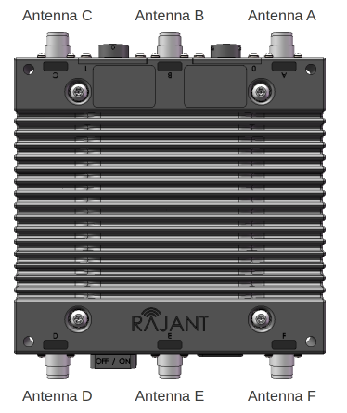

The BreadCrumb LX5 contains three radios in the 900 MHz, 2.4 GHz or 5 GHz bands.

* 2.4 GHz: Antenna A, C and F
* 5 GHz: Antenna B and E
* 900 MHz: Antenna D

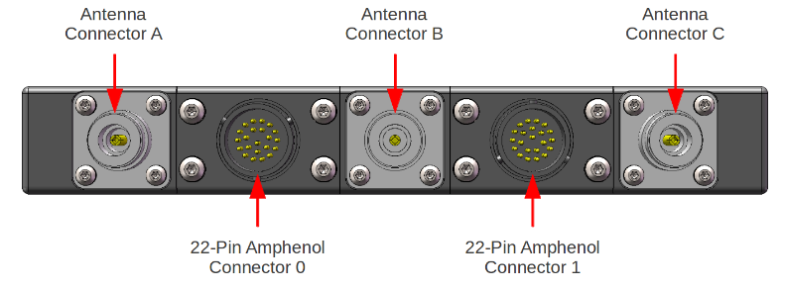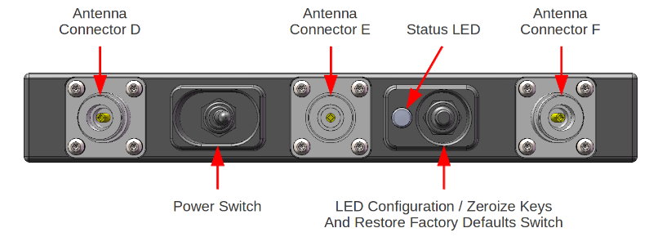

#### Part List

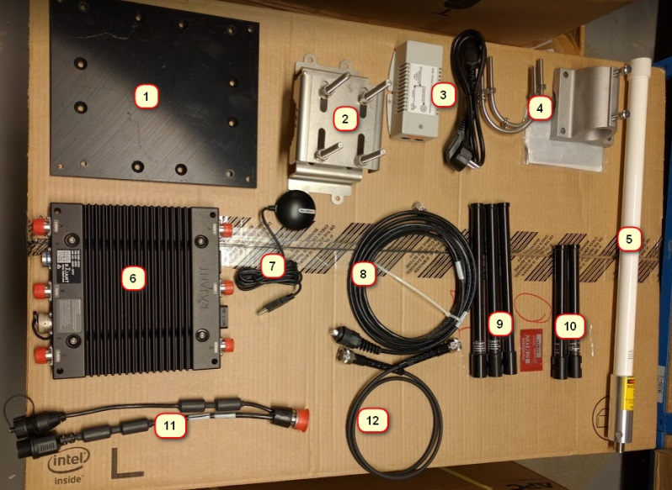

1. Mounting backplate
2. Mounting bracket + bolts and nuts
3. POE injector
4. Mounting bracket 900MHz antenna
5. 900 MHz antenna
6. Rajant LX5 node
7. USB GPS
8. 3m Ethernet cable with
9. 3 x 2,4 GHz antenna
10. 2 x 5 GHz antenna
11. Rajant spinkabel for Ethernet and USB GPS
12. Pigtail coax cable for 900 MHz
13. Self Amalgamating Tape
14. Electrical tape
15. Tie-rips

Optional: L- Profile + mounting plate

13. 14.



15.

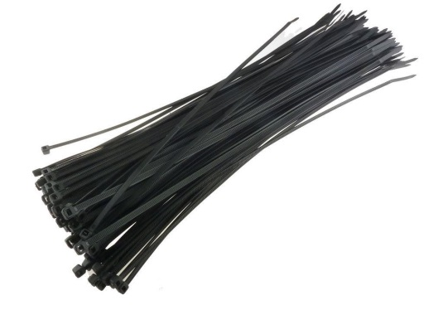

Rajant set without the tapes and tiewraps:

|  |  |  |  |
| --- | --- | --- | --- |
| 1217873 | *Rajant BreadCrumb (Node)* | 1 |  |
| 1107605 | *SpinCable* | 1 |  |
| 1107609 | *Ethernet afgeschermd* | 1 |  |
| 1121201 | *Kunststof plaat + beugels* | 1 |  |
| 1107613 | *PoE injector* | 1 |  |
| 1107616 | *GPS op USB* | 1 |  |
| 1107603 | *5.8hz antenne* | 2 |  |
| 1107602 | *2.4hz antenne* | 3 |  |
| 1100582 | *RFS RVS L-BUIS 1M50* | 1 | If needed |
| 1011094 | *Inox klem + beugels* | 1 | If needed |

### Juniper Firewall (SSG140, SSG 5 or Juniper SRX + EX)

The Juniper firewall is already installed on the vessels as part of the current IT infrastructure. The Juniper will act as router for all the traffic that will be sent and received over the wifi network.

On small survey vessels a firewall Juniper SRX 100 and a switch Juniper EX 3300 have to be provided with the Rajant.

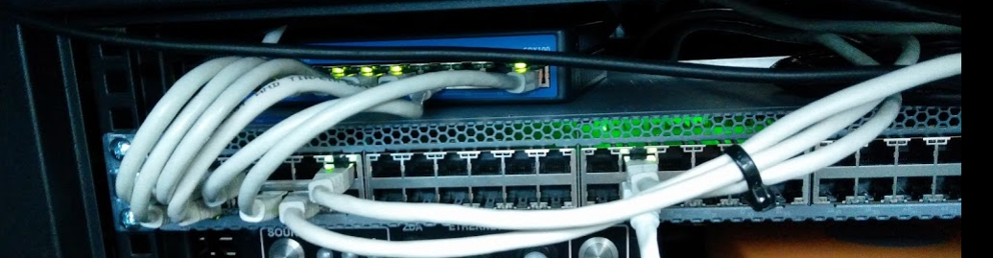

# Wifi Setup

## Hardware Setup

The Rajant system works like a full wireless mesh network, meaning that every vessel that is within range of another vessel will connect on the available radio frequencies. Below you can see an example

Every line between nodes represent a different radio frequency.

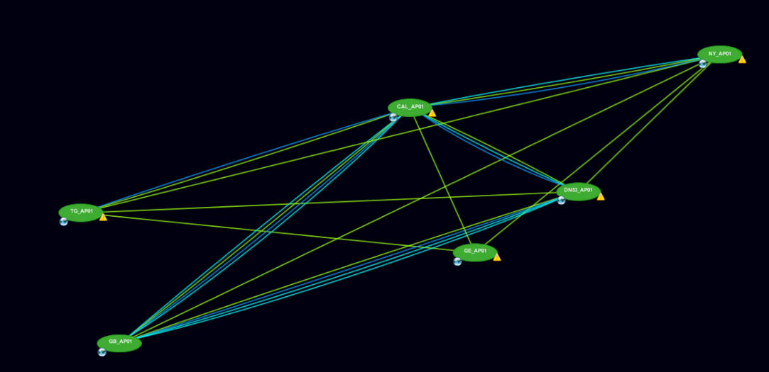

### Preperation of the Rajant LX5

A lot of the work for assembling a Rajant LX5 can be done in advance in the office. To complete this, you will need all items that were mentioned in 2.1.1.2 except for the POE injector (3). (please note that for all tapes please do not include the screw that are holding the connectors to the rajant unit).

1. To start, connect the spincable (11) to amphenol connector 0 on the rajant node. (amphenol connector 1 normally has a cap attached to it).
   1. Apply 2 layers of self-amalgamating tape so the connector including with 2 separate cables are covered
   2. Apply 1 layer of electrical tape so all self-amalgamating tape is covered.
   3. Fix one tie rip to keep the end of your rap from peeling off.
2. For the cap on amphenol connector 1 do the same steps.
   1. Apply 2 layers of self-amalgamating tape
   2. Apply 1 layer of electrical tape so all self-amalgamating tape is covered.
   3. Fix one tie rip to keep the end of your rap from peeling off.
3. Screw on all 2,4 Ghz antenna’s (9) to antenna connectors A, C and F. Best to tighten the antenna’s by hand as far as you can and another slight turn with a wrench.
   1. Apply 2 layers of self-amalgamating tape
   2. Apply 1 layer of electrical tape so all self-amalgamating tape is covered.
   3. Fix one tie rip to keep the end of your tape from peeling off.
4. Screw on all 5Ghz antenna’s (10) to antenna connectors B and E, same applies to tighten the antenna.
   1. Apply 2 layers of self-amalgamating tape so the connector including with 2 separate cables are covered
   2. Apply 1 layer of electrical tape so all self-amalgamating tape is covered.
   3. Fix one tie rip to keep the end of your tape from peeling off.
5. Screw the 900Mhz pigtail (12) to antenna connector D, same applies to tighten the antenna.
   1. Apply 2 layers of self-amalgamating tape, please include the full connector.
   2. Apply 1 layer of electrical tape so all self-amalgamating tape is covered.
   3. Fix two tie rips at the beginning and the end to keep the end of your tape from peeling off.
6. Screw on the 900Mhz antenna (5) to the other end of the pigtail
   1. Apply 2 layers of self-amalgamating tape, please include the full connector.
   2. Apply 1 layer of electrical tape so all self-amalgamating tape is covered.
   3. Fix two tie rips at the beginning and the end to keep the end of your tape from peeling off.
7. Connect the USB GPS (7) to the USB port of the spincable (11)
   1. Apply 2 layers of self-amalgamating tape, with the first layer of tape please create a x type shape that pulls the USB connector into the socket preventing bad or loose connections.
   2. Apply 1 layer of electrical tape so all self-amalgamating tape is covered.
   3. Fix two tie rips at the beginning and the end to keep the end of your tape from peeling off.
8. Connect the 3M Ethernet cable with custom screw connection (8) to the Ethernet socket on the spincable (11)
   1. Make sure both screw points on the connector are tightened as good as possible.
   2. Apply 5-7 layers of self-amalgamating tape, please include the full connector.
   3. Apply 2-3 layer of electrical tape so all self-amalgamating tape is covered.
   4. Fix two tie rips at the beginning and the end to keep the end of your tape from peeling off.
   5. (optional) If the cable that is provided on board of the vessel is suited to fix a regular cat6 UTP plug then this can be skipped.
      1. Cut the connector from the 3M cable (8) and fix this directly to the UTP that is provided on board of the vessel. Continue from a.
9. Assemble the mounting bracket (1) + (2) with the bolts and nuts.
10. Fix the 900Mhz antenna (5) to the mounting bracket (4)
    1. (optional) apply thin layer of the rubber that is included. (you will have some left)
    2. Please follow this order to fix the bolt
       1. Washer
       2. Nut
       3. Bolt
    3. Tighten the bolt
    4. Tighten the nut.
11. Fix the complete assembled unit to the mounting bracket
12. (optional) if you have a L-profile that has to be fixed with a separate bracket you can already mount the 900Mhz antenna to the horizontal part of the profile and the full rajant node to the top of the vertical part.

**!! Rajant unit must be mounted with the led indicator and on/off switch UP !!**

**!! Mount the GPS flat facing to the sky, else it won’t work!!**

Below you can find an example of a fully installed unit on the Pompei.

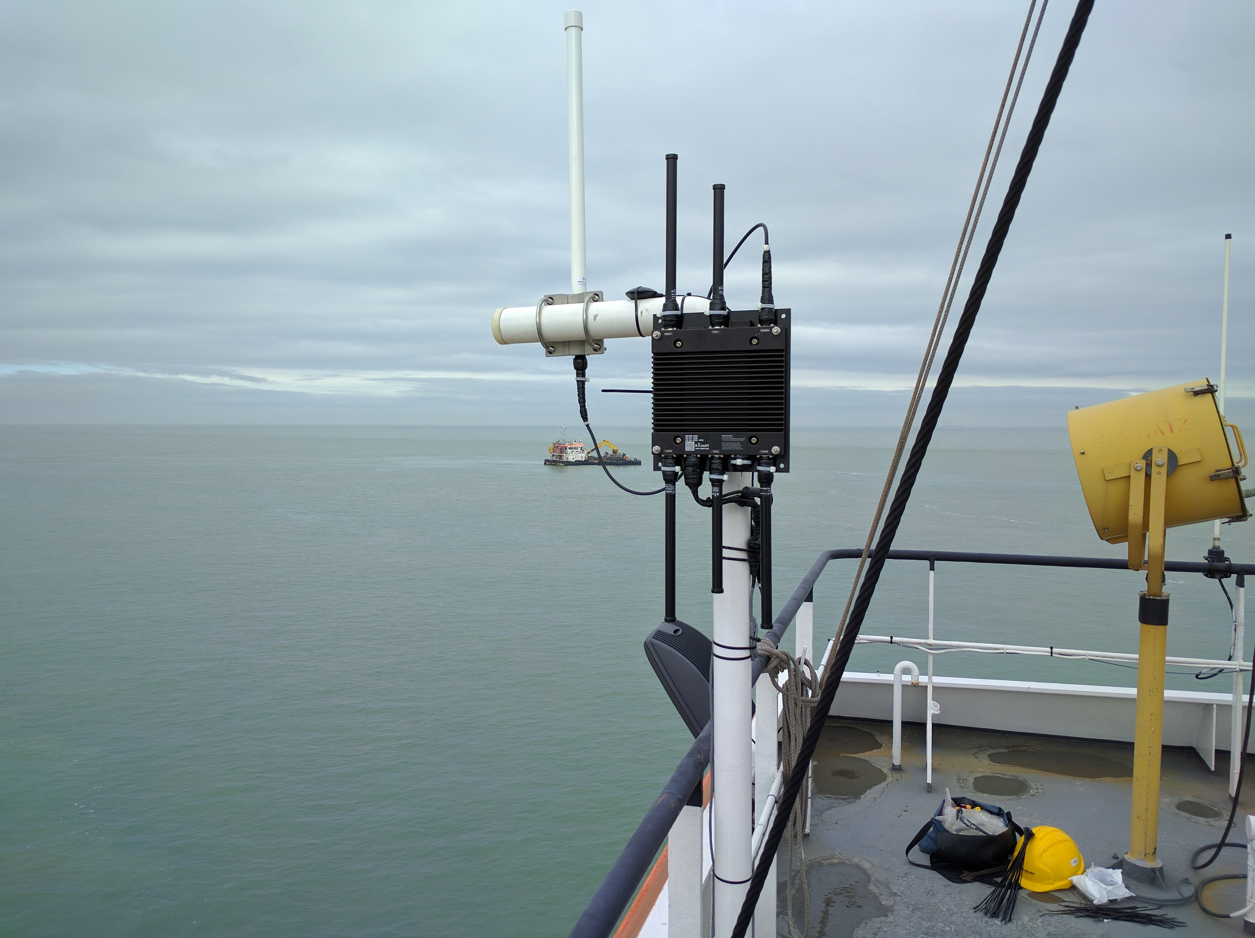

### Installation on the monkey bridge or mast

Because of the variety of available frequencies, we need different antenna’s to connect this all together. The best way to install a full rajant node is to use a L profile where the vertical part of the profile is around 200cm and the horizontal part of the profile is around 30 cm. diameter of the pipe should be 5-6 cm. Below you can find some examples;

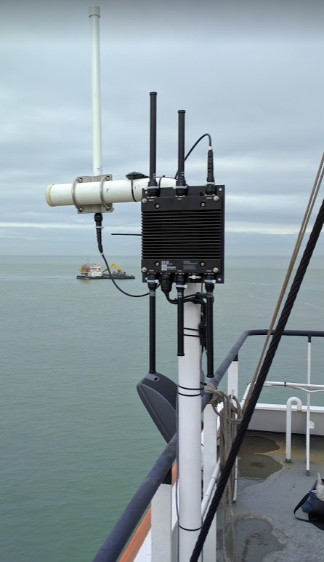 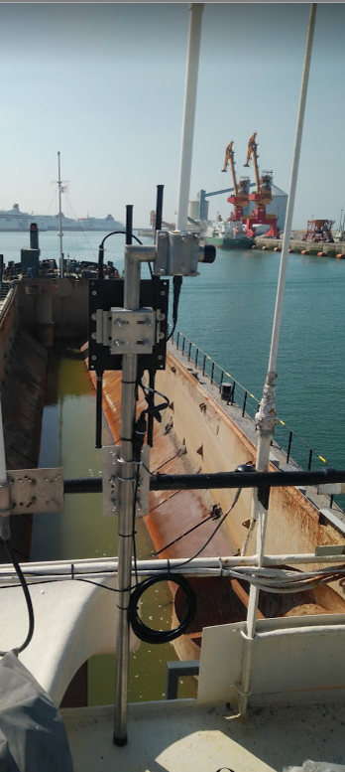 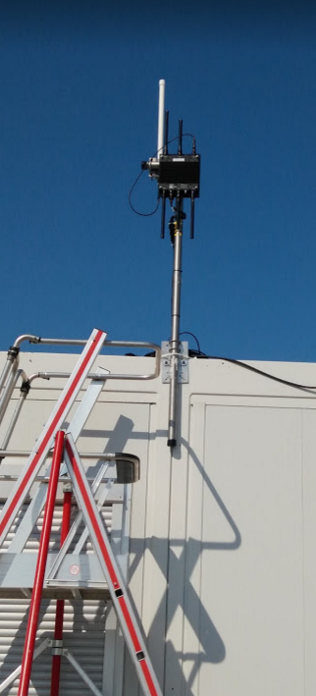

As mentioned above in section 3.1.1 step 6 depending on the network cable that is used. If it is not possible to fix a normal UTP plug (typically CAT6A or CAT7 cable) then you will need to fix a female UTP plug and use the full 3M cable provided.  
If it possible to fix a normal UTP plug cut the screw connector from the provided 3M cable and apply it to the cable on board.

### Installation in the converterroom (or location of Juniper)

Connect the network cables as indicated below.

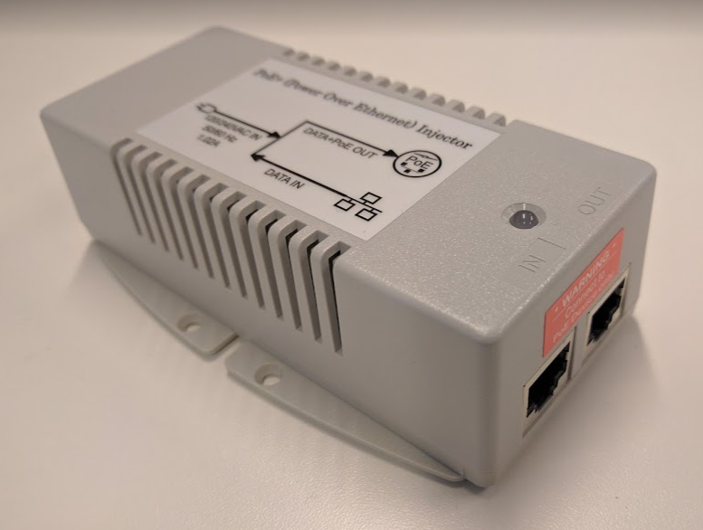

On the LAN side of the power injector  
there is a UTP patch cable connected to the Juniper:  
Juniper SSG 140 🡺 on port eth0/7  
Juniper SSG 5 🡺 on port eth0/6

Juniper EX switch 🡺 on the WIFI AP01 port

On the OUT side of the power injector the UTP cable from the rajant on the monkey bridge is connected

## Configure the Rajant

Rajant Overview.xlsx: <http://meso.jandenul.com/meso-webtop/drl/objectId/090236ed83d257e0>  
In the following excel you can find all the IP addresses that already in use, please fill in the excel file and save.  
> IP Rajant  
> IP Default gateway  
> Serial number  
> Name  
> Firmware

Make sure the BCCommander tool is installed on your device:  
BCCommander: <http://meso.jandenul.com/meso-webtop/drl/objectId/0b0236ed83d175f5>

Download Firmware: <http://meso.jandenul.com/meso-webtop/drl/objectId/0b0236ed835b8d6a>  
Download Config: <http://meso.jandenul.com/meso-webtop/drl/objectId/0b0236ed83b1fbe1>

Make sure you have the Passwords for the Rajant >> these can be found in RDM

After you have set your IP@ to   
IP address: 10.99.205.250  
Subnet mask: 255.0.0.0

Open BB|Commander and wait till he sees the Rajant.  
Login >> co >> breadcrumb-co

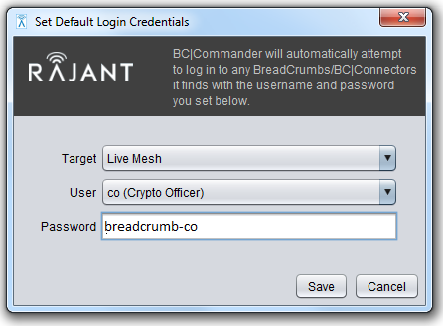

1. Right click >> Upload Firmware

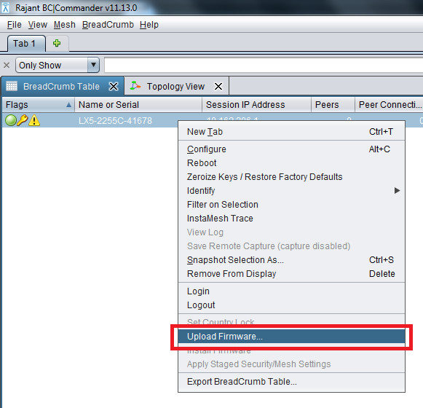

2. Click Choose to select the Firmware on your device

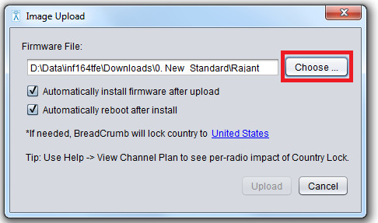

3. Select the *.flash file >> Click Open

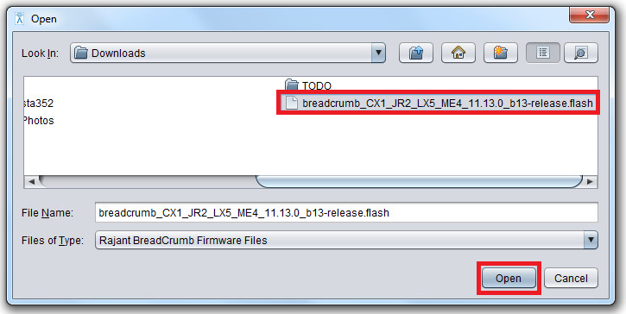

4. Make sure to select both check boxes >> Click Upload

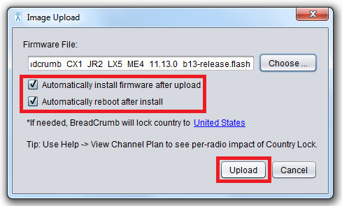

5. Wait till he is done, you can follow the progress under Task Status

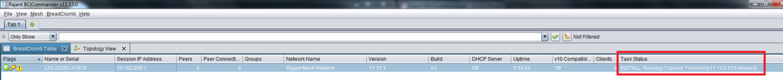

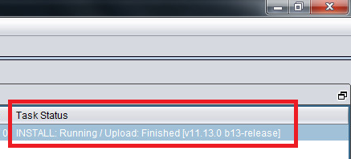

>>>>

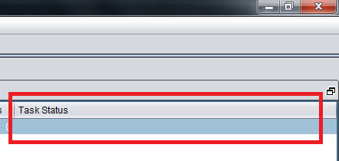

6. Right click the Rajant >> Click Configure

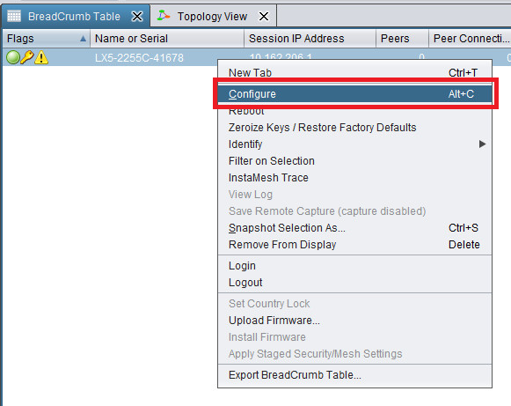

7. Click Import

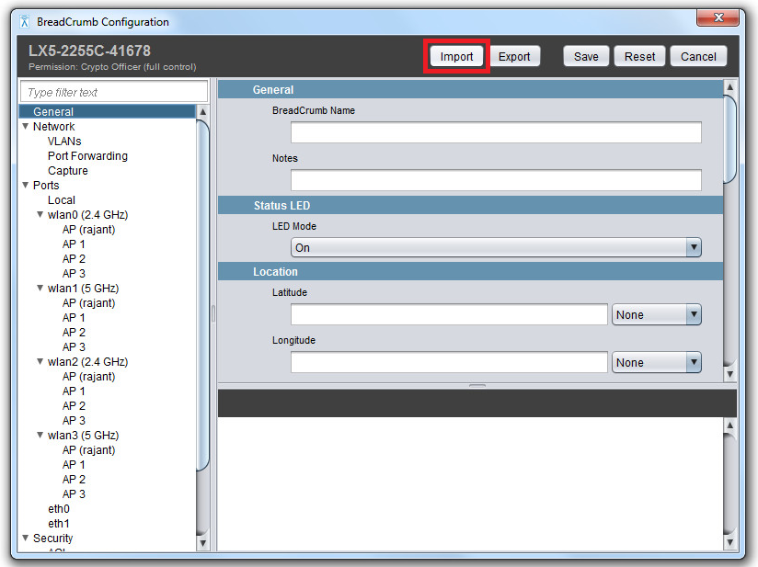

8. Click Select and browse to the folder where the config file is located  
>> Select the config file you want to import  
>> Check if all the checkboxes are markes  
>> Click Finish Import ( Settings will be changed later )

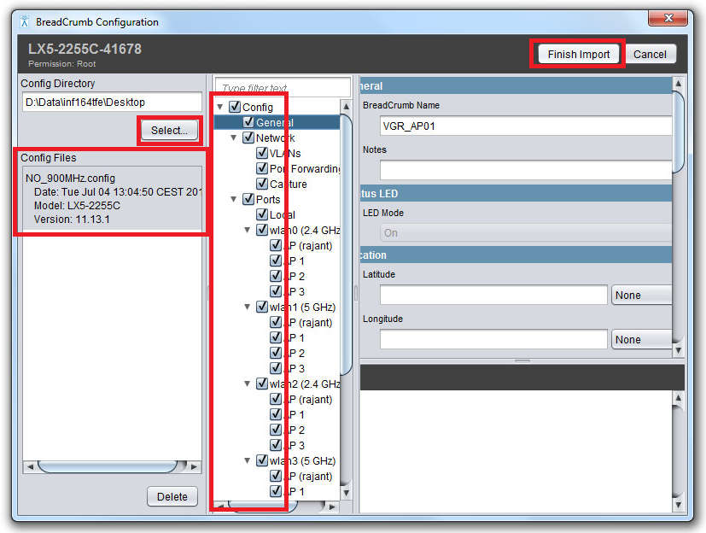

9. Change the BreadCrumb Name >> [Short site/vessel name]_AP[sequence number of the node]

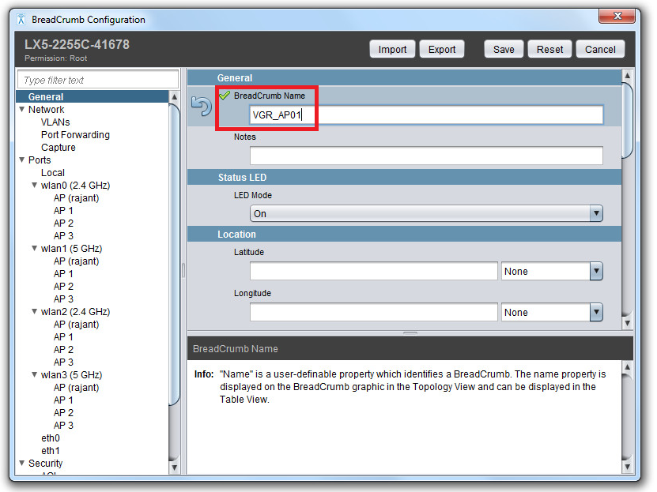

10. Change the Network Name and IP address of the Rajant  
>> The IP address can be found in the Template JUNOS Switchen en Firewalls.xlsm  
>> IP WIFI is the default gateway || The IP address is +1 || Subnet 255.255.248.0  
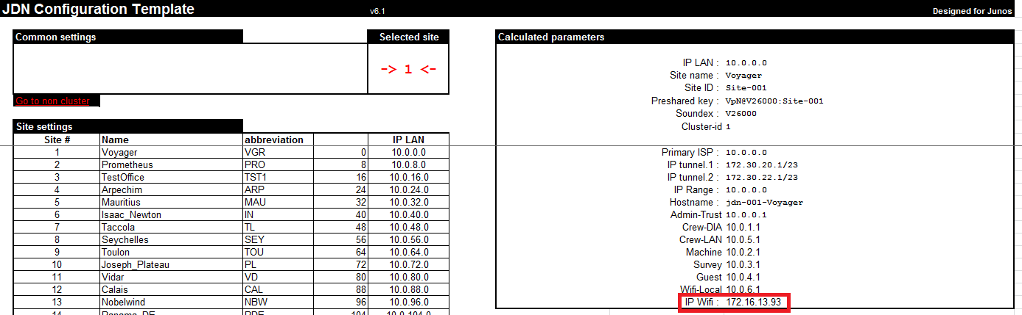  


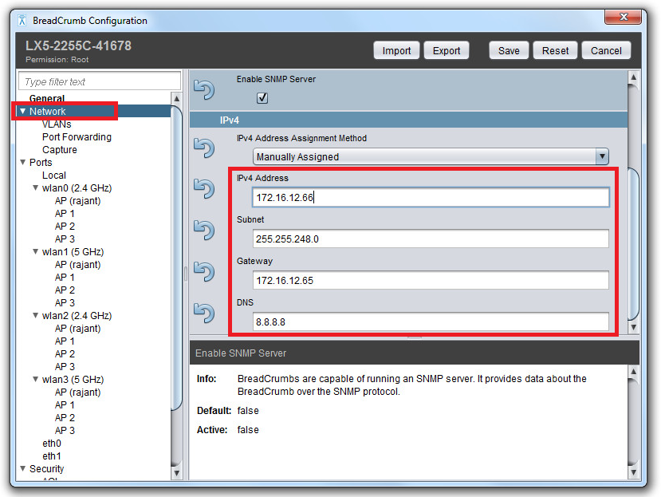

11. Set the network password ( Can be found in RDM )

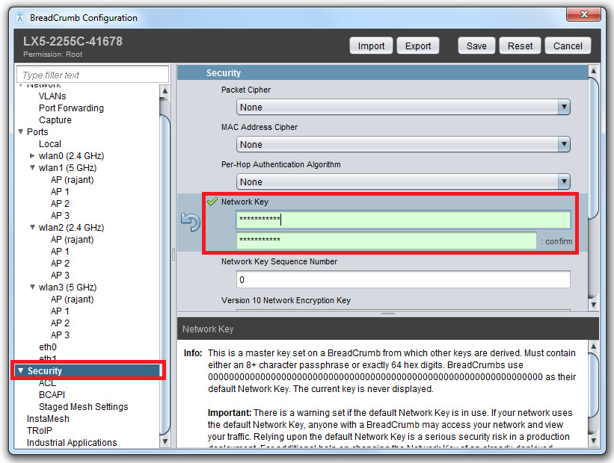

12. Set the login passwords ( Can be found in RDM )

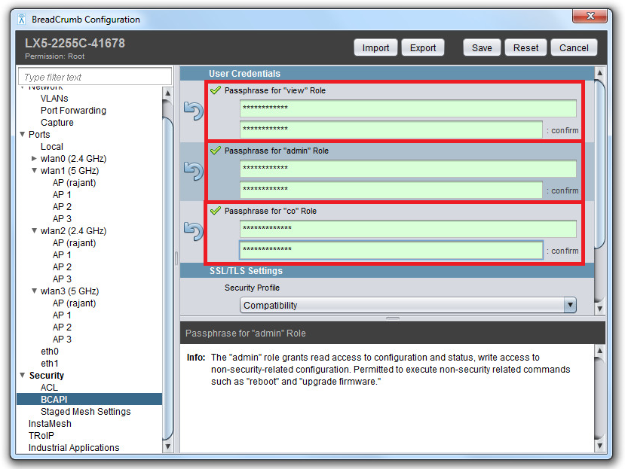

13. Click Save

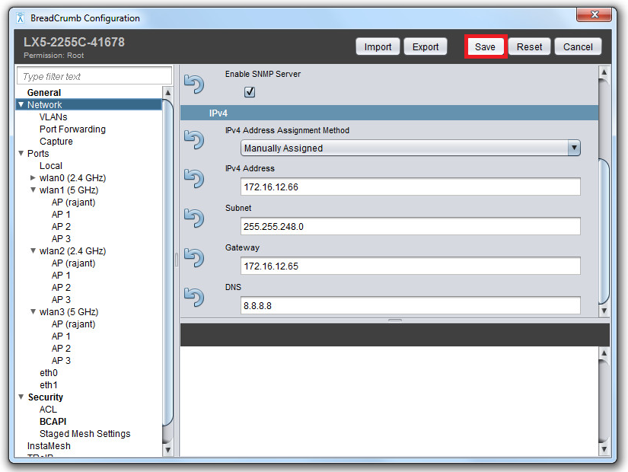

14. Click reboot

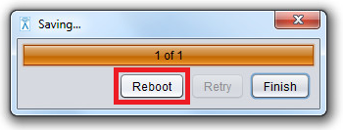

15. Set your own network card to the following parameters:  
IP@ 172.16.8.2  
Subnet mask: 255.255.248.0

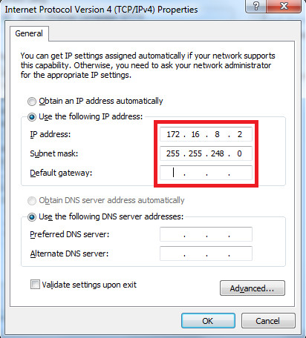

16. If the Rajant doesn’t show the new IP address >> Click Mesh >> Click Scan for BreadCrumbs

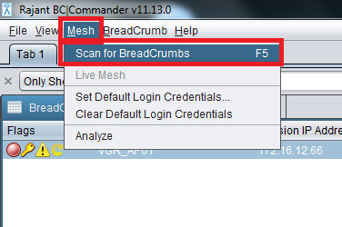

17. Relogin on the Rajant, because you set a new password

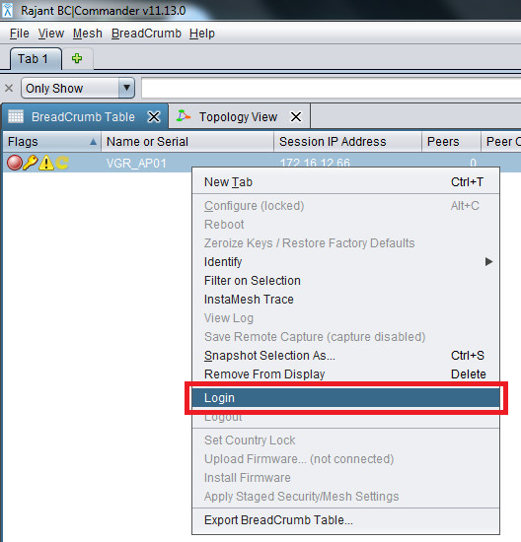

>> Make sure to login as co (Crypto Officer)

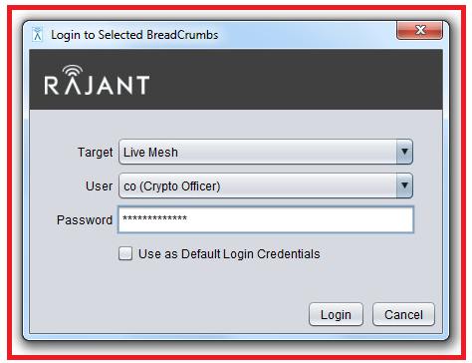

# Juniper / routing / policy

## Juniper SSG

If you have to install a new node on a vessel with an old Juniper SSG please ask SA / SE to push the correct config for rajant wifi install.

Normally they know what to adjust and the only info they need is the IP of the rajant and the IP for the wifi interface on the Juniper.  
Just to be sure below you can find a list with all the adjustments.

1. Correct IP address on the wifi interface.
2. Track-ip disabled on wifi interface
3. OSPF enabled on interfaces for trust, machine and wifi
4. Remove default route to wifi in trust-vr
5. Correct policies
   1. From trust to wifi and from wifi to trust
      1. RDP and Ping between fileservers on site
   2. From machine to wifi and from wifi to machine
      1. Has to be decided on project base.

## Juniper SRX ( Check below settings normally it is already OK )

### Already installed new setup

* Adjust the IP on the firewall reth14.400
* Ask SA / SE to sync changes in space
* Change policies according to what is needed on project
  + Default permit all from all zones to wifi
  + Default deny all from wifi to all zones (once in sync in space).

### New small setup for survey vessel

* Apply config to juniper ex3300 and srx240 for small setup
* Ask SA / SE to import into space
* Change policies according to what is needed on project
  + Default permit all from all zones to wifi
  + Default deny all from wifi to all zones (once in sync in space).

# Troubleshooting

When a problem is reported please follow these steps.

* Check connectivity (from the vessel) to the AP
  1. If a Wifi management PC was installed on site with the BCCommander software you can check if the AP is online
  2. If there is no Wifi management PC login to the juniper of the concerning vessel/endpoint and check if you van ping the node.
* 2 possible ways to continue

1. If the AP is online but still no communication is possible, check all following items on the firewall.
   * 1. Correct IP address on the wifi interface.
     2. Track-ip disabled on wifi interface
     3. OSPF enabled on interfaces for trust, machine and wifi
     4. Remove default route to wifi in trust-vr
     5. Correct policies
2. If the AP is not reachable follow these steps
   * 1. Reboot the AP via the POE injector
     2. Make sure that everything on the node is still taped of and no water has got in the Ethernet connector.

**Special case**: if the node is powered but you are still not able to reach the node

**2 possible solutions**

* The network cable is not terminated correctly.
* Config is corrupt
  + Factory reset the unit and re apply the config to the unit.

***Factory reset Rajant LX5***

This mode is is used to erase the security protocol keys of a BreadCrumb LX5 and to restore its software configuration to the factory default state. To operate this switch follow these procedures:

Ensure that the BreadCrumb is powered on, has fully booted-up and its Status LED color is green or blue.

Press and hold the switch until the Status LED changes to blinking yellow (approximately 10 seconds), then release the switch.

The Status LED will flash the yellow warning code “321” (BreadCrumb is being zeroized) then flash rapidly yellow. This indicates that the Zeroize Keys and Restore Factory Defaults operation has been initiated and is in progress.

The Status LED should flash the red error code “32” (BreadCrumb has been zeroized). This error code will flash for up to 30 seconds.

The BreadCrumb will then automatically reboot using the factory default configuration.